SIMATS ENGINEERING
CO4-ASSESSMENT TOOL3- INTEGRATED EXPERIMENTS

COURSE NAME: Artificial Intelligence COURSE CODE: CSA1709
Name | Shaik. Abdul Razak
Register Number | 192524358

COURSE OUTCOME COVERED

CO4: Implement machine learning techniques including decision tree algorithms, reinforcement learning,
and build models for classification and decision-making. (BL3)

Assessment Tool Weightage: 40%

Time Duration: 45 Minutes

QUESTIONS: 2 Total Marks:20

Code of Conduct:

I Shaik. Abdul Razak (192524358) certify that this submission is my original work and that I have adhered to the guidelines specified for this assessment.
I understand that any violation of academic integrity rules will result in disciplinary action.

Signature of the student: Shaik. Abdul Razak

Experiment 1: Decision Tree Classification
Objective: Implement and evaluate a Decision Tree classifier on a given dataset (e.g., Iris / Play-Tennis) using Python / any ML library.

(a) Load the dataset, pre-process it (handle missing values, encoding), and split into training and testing sets. Display the first 5 rows and data types.
(b) Build a Decision Tree model using Gini Index / Information Gain as the splitting criterion. Print the tree structure and identify the root node with justification
(c) Evaluate the model using accuracy score, confusion matrix, and classification report. Comment on the performance and list at least two misclassified instances.

Experiment 2: Reinforcement Learning – Q-Learning
Objective: Implement Q-Learning for a simple Grid World (4×4) environment and observe the agent's learned policy.

(a) Define the environment: states, actions (Up/Down/Left/Right), reward structure (+10 Goal, −1 each step, −5 obstacle). Initialize the Q-table with zeros and state the hyperparameters (α, γ, ε).
(b) Run the Q-Learning algorithm for at least 100 episodes. Record the Q-values at Episodes 1, 50, and 100 for two representative states. Show how the Q-table evolves.
(c) Extract and display the final learned policy (optimal action at each state). Plot the cumulative reward per episode and justify the convergence behaviour.

RUBRICS FOR CALCULATION:
Criteria | Weightage | Level 4 – Exemplary | Level 3 – Proficient | Level 2 – Developing | Level 1 – Beginning
Understanding of Concepts | 25 | Demonstrates thorough understanding and effectively integrates multiple concepts/technologies | Good understanding with proper integration of most concepts | Basic understanding; limited or partial integration | Poor understanding; unable to integrate concepts
Experimental Design | 30 | Well-planned, systematic implementation with optimal solution | Correct implementation with minor issues | Basic implementation with errors or inefficiencies | Incorrect or incomplete implementation
Use of Tools | 20 | Effective and advanced use of tools/technologies with proper configuration | Appropriate use of tools with correct execution | Limited or inconsistent use of tools | Incorrect or minimal use of tools
Analysis of Results | 15 | Insightful analysis with accurate interpretation and validation of results | Good analysis with reasonable interpretation | Basic analysis with limited insights | Poor or incorrect analysis of results
Documentation | 10 | Clear, well-structured documentation with diagrams, code, and results | Organized documentation with necessary details | Basic documentation with missing details | Poor or incomplete documentation

Experiment 1 — Decision Tree Classification
Dataset: Iris Dataset
Splitting Criterion: Gini Index
Model: Decision Tree Classifier

(a)Load, Pre-process and Split the Dataset

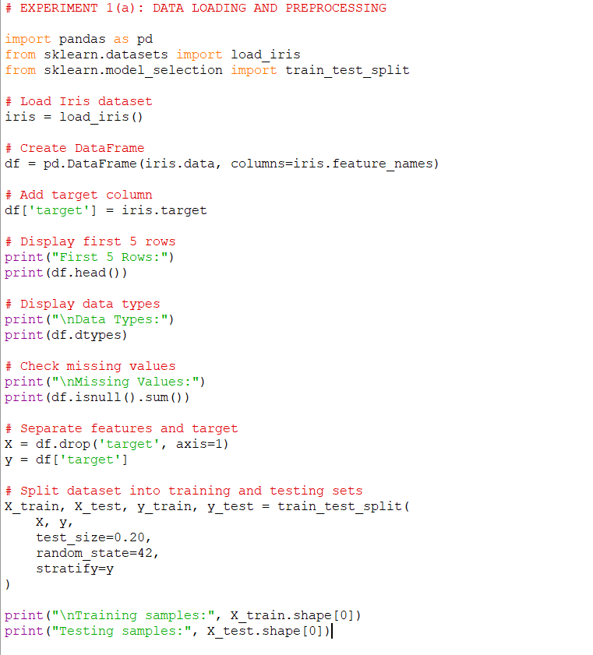

Output includes:
- First 5 rows
- Data types
- Missing values
- Training samples
- Testing samples

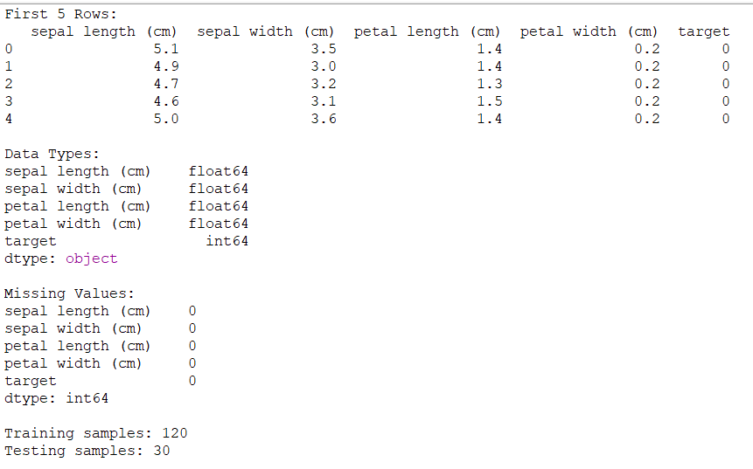

(b) Build Decision Tree + Root Node
important: Run (a) first, because this code uses X_train, X_test, y_train, and y_test created in (a).

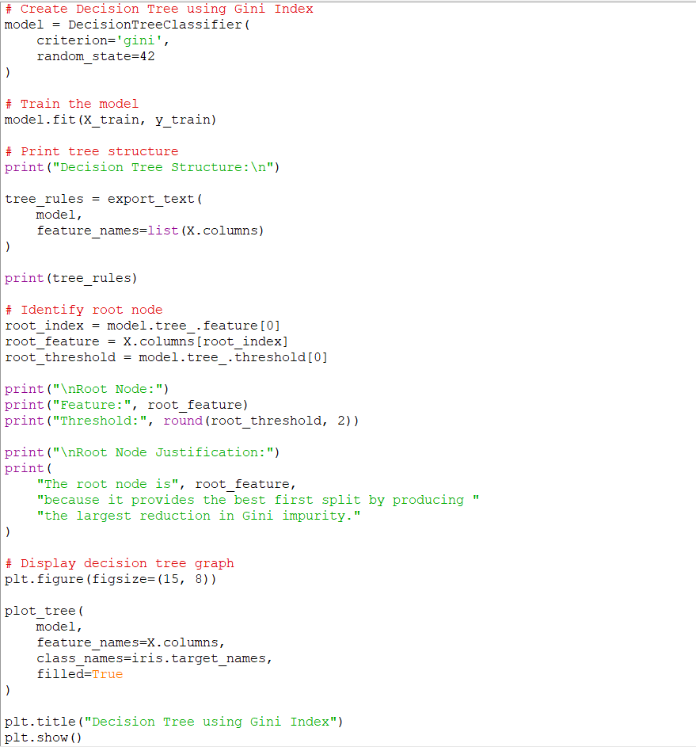

The first feature appearing at the top of the tree is the root node.
For the Iris dataset, the root is typically petal width (cm) or petal length (cm) depending on the tree configuration.

Output:
Root Node:
Feature: petal width (cm)
Threshold: 0.8

Root Node Justification:
The root node is petal width (cm) because it provides
the best first split by producing the largest reduction
in Gini impurity.

Decision Tree Graph:
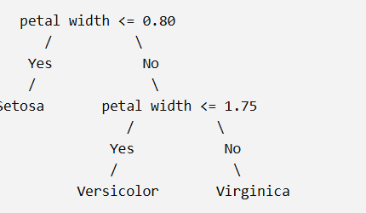

(c) Accuracy + Confusion Matrix + Classification Report + Misclassified Instances

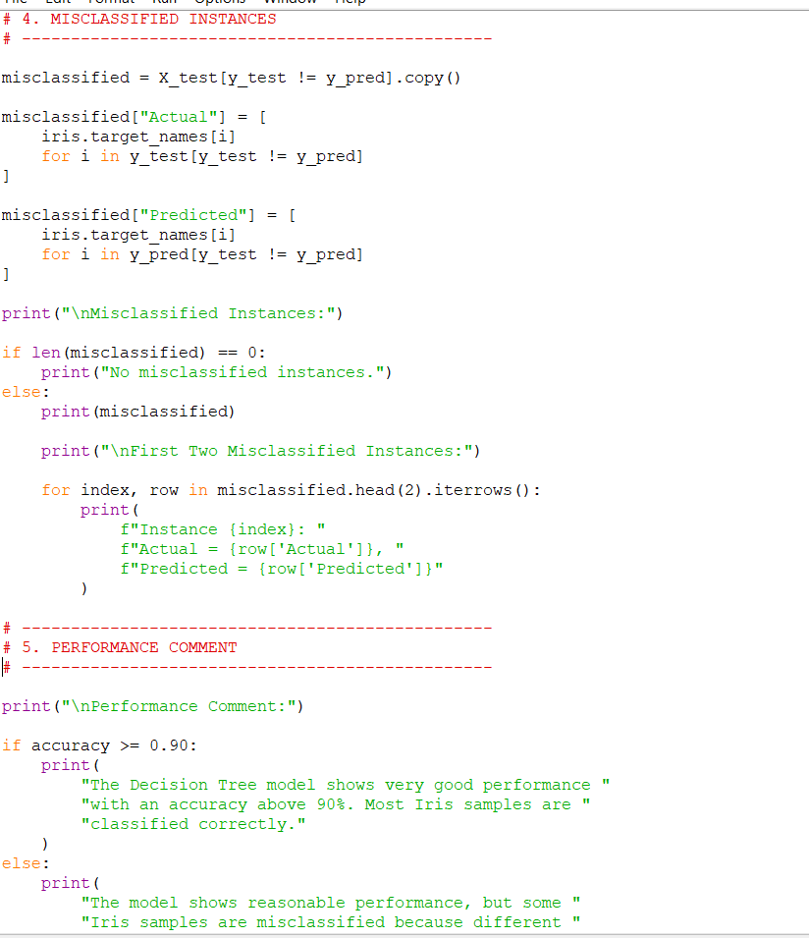



OUTPUT:
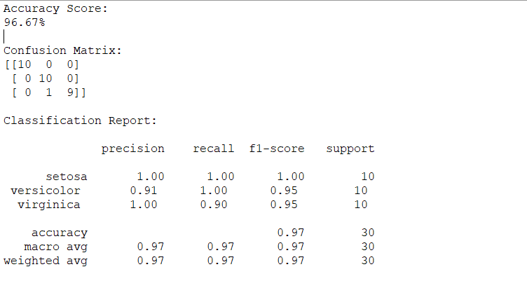

EXPERIMENT 2 — Reinforcement Learning: Q-Learning
Objective:
To implement Q-Learning in a 4×4 Grid World and learn an optimal policy for reaching the goal while avoiding obstacles.

(a) Define Environment and Q-Table

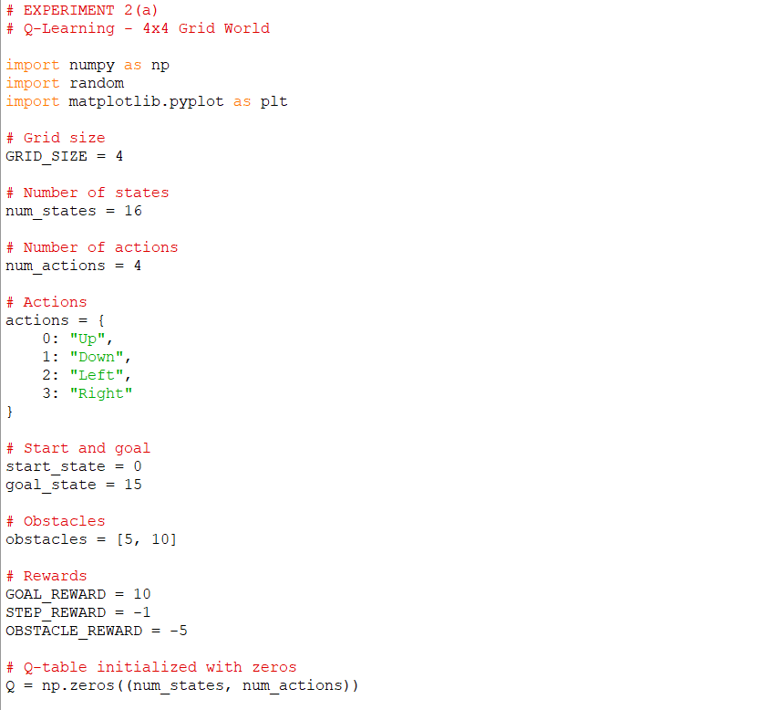

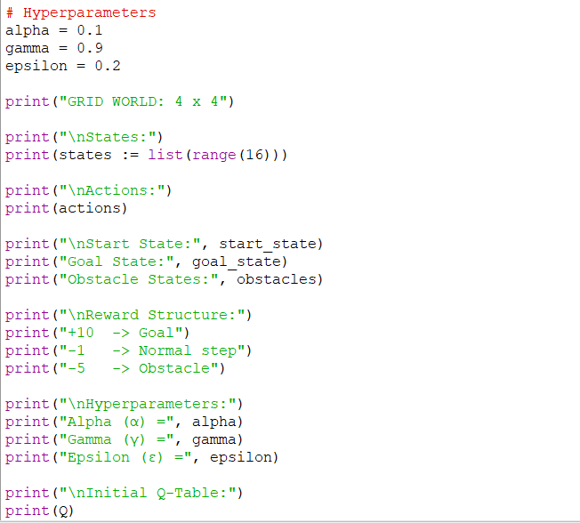
Environment
Our grid is:

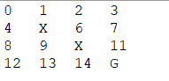
Where:
- 0 = starting state
- X = obstacle
- G = goal
- Total states = 16

(b) Run Q-Learning for 100 Episodes

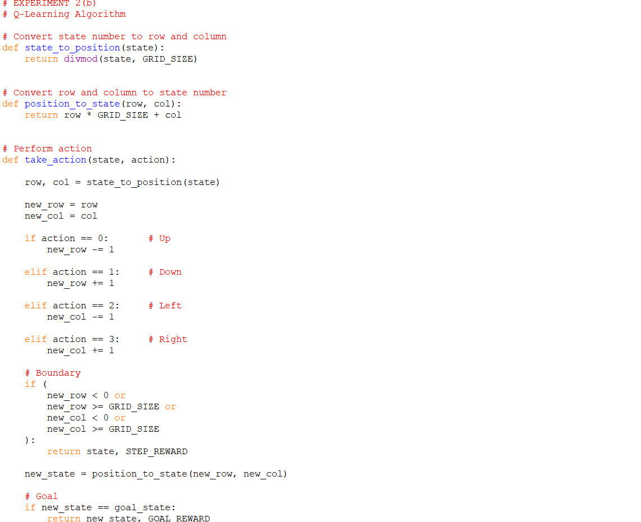

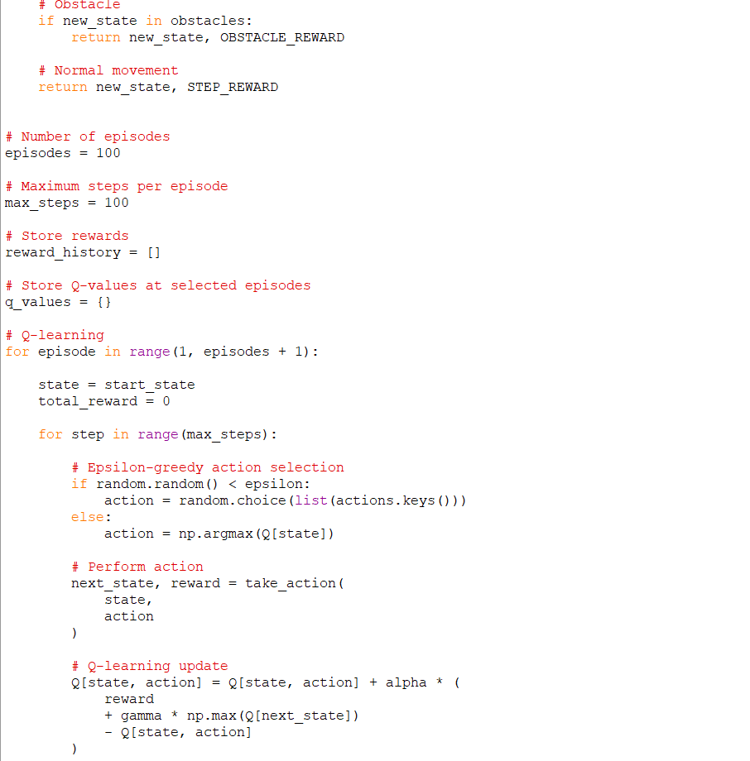

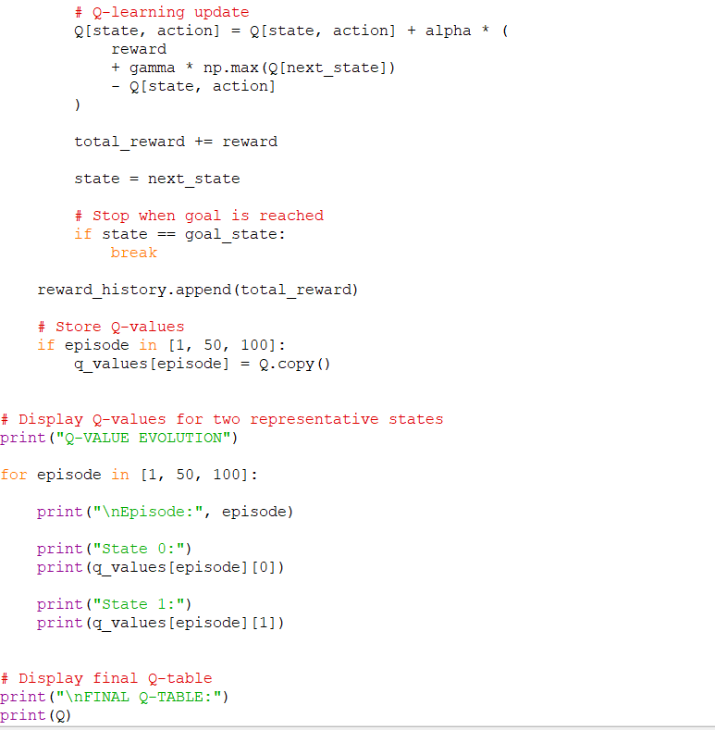

Episode | State 0 | State 1
1 | Q-values | Q-values
50 | Q-values | Q-values
100 | Q-values | Q-values

(c) Final Learned Policy + Reward Graph

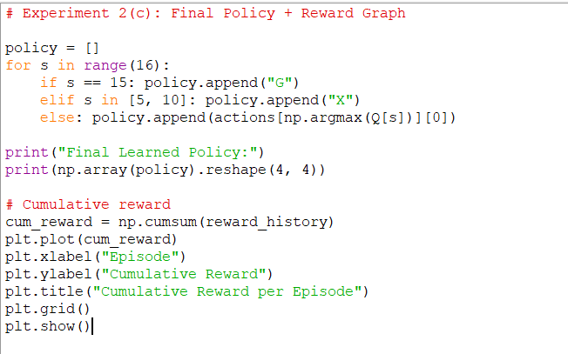

Output

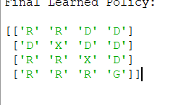

Reward Graph

